U.S. Federation of Worker Cooperatives Dental Plan

Welcome to the United States Federation of Worker Cooperatives (USFWC) Dental Plan! This dental plan started because it’s so hard for small cooperatives to get a good dental plan that doesn’t have hidden terms and surprise costs. This plan is transparent, affordable, and easy to use.

This document outlines the requirements to participate in the USFWC Dental Plan. In order to have a sustainable plan. We must have some standard guidelines.

Dental Plan Overview

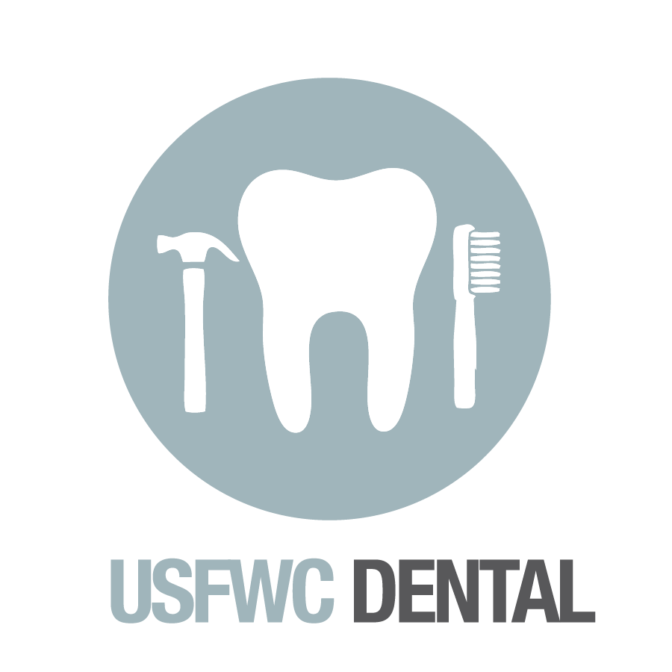US Federation of Worker Co-ops Dental Summary
Plan | Preferred Provider Organization
Deductible | $50 per person ($150 max per family)
ANNUAL MAX | $1,500
Type A Services (Preventative): Exams, X-rays, Cleanings, Fluoride Treatments, Sealants, Palliative Treatment (emergency) | $0 copay (deductible waived)
Type B Services (Basic Restorative): Oral Surgery, Periodontics, Extractions, Endodontics, Fillings, Basic Restorative Services, Complex Oral Surgery, General Anesthesia, Space Maintainers, Repairs of Crowns, Bridges, Dentures | You pay 0-20% of costs after deductible
Type C Services (Major Restorative): Inlays, Onlays, Crowns, Prosthetics (Bridges & Dentures) | You pay 50% of costs after deductible
Orthodontics | You pay 50% coverage ($1000 lifetime benefit maximum per child)
Ortho Lifetime Max | $1000 per child (children only)
Family Status | Monthly Premium
Single | $35.80
Employee + Child(ren) | $72.50
Couple | $70.40
Family | $116

Out of network benefits will be the same as in-network benefits. Please be advised that there is a possibility that you will have to pay extra if your dentist is among the most expensive 10% of providers. You will only have to pay extra if your provider is amongst the top 10% most expensive in your area. The extra amount will most likely be small though.

Most dental plans for small groups & individuals are pretty terrible. The reason for that is most dentists that perform the Type B & C procedures DON’T accept dental insurance. For example, the dentist wants to charge $1200 for a crown (Type C service, you pay 50% after $50 deductible). But the insurance company only wants to pay them $700. So the dentist prefers to be out of network. They’ll still run the claim through insurance, but the insurance company says “50% of $700 is $350, minus the $50 deductible, so the check is made out for $300”. Your dentist applies the $300 payment, and bills you the rest… $900. Not exactly what you were expecting when you saw 50% right?

With this plan, the insurance company will pay 50% of $1200.

Also, one person can only ever have a $50 deductible, so if you have 6 family members, each will max out at a $50 deductible. If all of you need Type B or C services to which the deductible applies, then only the first 3 of you will be required to pay the deductible.

The USFWC plan has an excellent out of network reimbursement, so feel free to see any dentist you want and you can be reasonably sure that 50% will mean 50%!

Participation Requirements

Each USFWC Dental Plan member will be required to pay at least 50% of the employee only premiums on behalf of any full time employee. You can define “full time employee” as an employee working anywhere upwards of 25 hours a week. You have flexibility in there. Where you do not have flexibility is that you must pay for at least 50% of the employee only premium for anyone you define as “full time”. This is a requirement to ensure adverse selection does not occur and that the plan will be sustainable for everyone for many years.

Workplaces may pay more than the 50% minimum. We strongly encourage workplaces to pay as close as possible to 100% of the cost because it is in the best financial interest of both the business and the worker.
Administrative Fees

The plan does require quite a bit of work to maintain. We need to charge a small administrative fee in order to cover our overhead in running the plan for our members. The monthly fees are as follows:

- 2-10 employees = $5 per month
- 11-25 employees = $10 per month
- 26 or more employees = $15 per month

This fee will be included in your dental plan invoices and should be less than 2% of your total costs for the dental plan. This plan is covered by the Consolidated Omnibus Budget Reconciliation Act (COBRA) and the USFWC will handle that process as well. However, it is your cooperative’s responsibility to provide the initial rights notice to employees (informing workers of their access to this plan). We recommend including it in your onboarding materials for new hires.

Payment of Premiums

USFWC will send you a monthly invoice for the dental plan. We take a “snapshot” of everyone who is enrolled on the 3rd day of the month, then bill you according to that snapshot. New employees can only enroll starting at the beginning of a month. Any employee who leaves the company or discontinues coverage will be removed from the insurance on the last day of the month. We recommend paying premiums via ACH or recurring payments via DWOLLA. Our DWOLLA info is 8125337483
If you are unable to pay electronically, we do have a check processing fee of $15 per check if you are going to mail a check.

Payment must be received by the 20th of each month or the insurance coverage will be discontinued for your group. There is a 30 day grace period in order to re-install coverage by paying any outstanding premiums.

Notification

All notices hereunder and communications regarding interpretation of the terms of this contract and changes thereto, shall be effected by the mailing thereof by registered or certified mail, return receipt requested, postage prepaid, and addressed as follows:

USFWC
1904 Franklin Street, Ste 400
Oakland, CA 94612

Agreement

The two parties to this agreement hereby agree that this agreement constitutes the entire agreement which is made and concluded between the two parties. The USFWC member entering into this agreement acknowledges and accepts the above requirements and fees.

Both of these parties for and in consideration of the payments to made, conditions mentioned, and work to be performed; each agree to diligently perform in accordance with the terms and conditions of this agreement as evidenced by the signatures below.

Company: | U.S. Federation of Worker Cooperatives
By: | By: Esteban Kelly
Title: | Title: Executive Director
Date: | Date:

